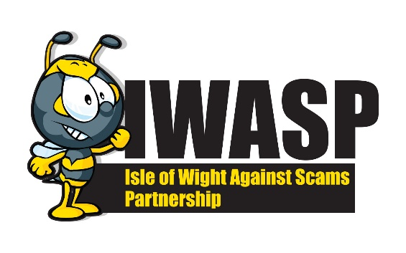
GUIDE TO BANKING AND CARD FRAUD

Cash Machines
When using a cash machine remain alert, criminals can target users to steal their cards or cash. Fraudsters can also attach devices to the machines that trap bank cards, copy the card details and record the PIN.
- Be vigilant when withdrawing money from any cash dispenser
- If there appears to be anything unusual about a machine, such as signs of tampering, don’t use it and report your concerns.
- If your card is retained by a machine contact your card provider immediately
Cards and Contactless Payments
Contactless payment uses a wireless chip containing the user’s payment card details, this enables the user to make payments of up to £100 by passing their card a few centimetres from a suitable card reader.
- Every contactless card has an inbuilt security check which means you occasionally have to enter your PIN to confirm payment
- Never let your card out of your sight while someone is taking a payment, they could be using a skimming device to copy data from your cards magnetic strip or copying the CCV code on the back. This will enable them to clone your card and use it to the value of £100 multiple times
- You can purchase card holders that prevent anyone from cloning your card using mobile skimming devices.
- Monitor your bank accounts regularly to check for unknown payments
- If your card is lost or stolen report it immediately to your card provider
Online Banking
To stay safe while banking online you must protect your password and personal details to stop criminals from accessing your accounts
- Choose, use and protect passwords. Did you know that using 3 random words, a capital letter and a number will take a hacker about 100,000 years to crack!
- Don’t use the same password for every account.
- Keep online banking software and banking apps up to date. Always download updates when prompted
- If logging in in public make sure you shield any PIN codes or passwords
- NEVER use a public Wifi for any banking – there is no guarantee that this will be secure.
HOW TO CHECK OR REPORT
Citizens Advice Scam Line – 0808 250 550
Action Fraud - Action Fraud - 03001232040
Trading Standards – trading.standards@iow.gov.uk
Trading Standards – 01983 823371

