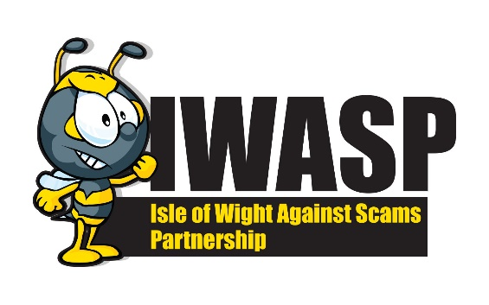
GUIDE TO ROMANCE FRAUD

Dating online has become increasingly popular with millions of people finding new relationships online unfortunately amongst the genuine profiles are fake profiles set up by fraudsters. They use deceit and manipulation, playing on vulnerability and emotions to steal your money.
How does the scam work?
Romance frauds happen when the victim thinks they’ve met the perfect partner through an online dating website or app, but the other person is using a fake profile to form a relationship with them. They’re using the site to gain the victim’s trust and ask them for money or enough personal information to steal their identity. They don’t just use dating apps, these types of fraudsters can be found in online gaming chat rooms and social media as well.
Fraudsters use very flattering language appearing really interested in their victim in a short space of time and will take the time to groom them and convince them that they are in a relationship. However, they will always find an excuse not to meet in person such as they are stuck overseas, family emergency or an issue with their business. It is then that they will start asking for money to help with their problems, providing a believable way of repaying you. They may seem desperate to meet up, but in reality their only desire is to take as much money as they can.
- Keep all communication on the dating website or app you are using
- Don’t be convinced by profile pictures, they may have been taken from the internet, you can check photos by googling reverse image search online
- Do some investigation on the person, are they members of other social networking sites? Can you confirm any information about them?
- NEVER send money to anyone you haven’t met in person and be extremely wary of giving money to someone who you have just started a new relationship with
- NEVER receive money for somebody and send it on to a third party – this is money laundering and is a criminal offence
- NEVER take out a loan for them
- NEVER give them copies of your personal documents – such as passport or driving licence
- NEVER invest your own money on their behalf or their advice
- The scammer will ask you lots of questions to find out as much about you as they can but will reveal very little about themselves in return
- Even if the person you are in a relationship with asks you to keep it a secret (which they will because they don’t want anyone putting any doubt in your mind) talk to friends and family about it
HOW TO CHECK OR REPORT
Citizens Advice Scam Line – 0808 250 550
Action Fraud - Action Fraud - 03001232040
Trading Standards – trading.standards@iow.gov.uk
Trading Standards – 01983 823371

