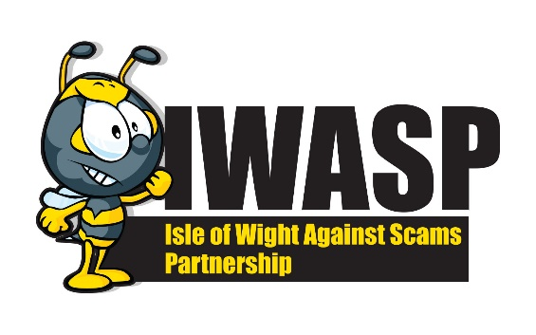
TIPS FOR STAYING SAFE ONLINE

Being able to spot a scam is not always easy but it really is the best way to avoid becoming a victim. Follow the simple advice below and prevent yourself from becoming a scam victim.
TEXTS – Scammers will use texts to not only gain access to our information but also our personal or banking details, examples include parcel delivery texts asking you to click on a link to pay for delivery or messages purporting to be from your bank. Don’t click on any links in suspicious messages. If you receive a scam text this can be forwarded to 7726 where it will be used as intelligence.
WHATSAPP– these messages have included supermarkets offering vouchers if you forward the message to 10 contacts – this is a phishing exercise – designed to collect yours and your friends details which can later be used in more elaborate scams. More recently we have seen Whatsapp messages that claim to be one of your children and they have lost/broken their mobile and using a temporary replacement. They wont be able to do online banking and have to make a payment and will ask you to do this on their behalf – this is a scam, if you receive this message ring your child and confirm with them.
EMAILS – These might be a message from somebody that you know saying that they have a problem – can you help them out. Your friends email account will have been hacked and scammers are relying on your good nature to pay them money. If you aren’t sure ring your friend and ask if all is ok – at the very least you will notify them that their account has been hacked and they can change their password to protect themselves. Scam emails can look very official and genuine such as TV licence renewals, Driving Licence renewals. Always check the senders email address – if it is genuine it will end in the organisations genuine address. Scam emails are generally random/personal email addresses and therefor you can tell that they aren’t genuine. Scam emails can be forwarded to report@phishing.gov.uk where they can be used as intelligence
SOCIAL MEDIA – As with emails any message relating to money from a friend should be treated with caution. Scammers are cloning facebook accounts then messaging everyone in their account to either ask for money or to advise about an amazing financial opportunity. Do not respond to these requests – contact your friend and ask them if its really them – again you will have alerted your friend that they have been hacked and prevented yourself from losing money to scammers. You and your friend should both change your passwords
ONLINE SHOPPING – When shopping online always use a trusted site – whilst its tempting to go for the cheapest option you can find, many of these websites don’t operate in the UK and aren’t subject to our consumer laws so if there are problems exchanges and refunds can be difficult. Always check the URL for a green padlock or https – these both denote that your payment and personal details are secure however be aware this doesn’t guarantee that the seller is a trusted seller and that you wont have problems.
Check reviews before you make a purchase.
Be aware of copycat websites, these will often appear at the top of a web search such as applying for a passport, driving licence, blue badge – they will have paid to be at the top of the search and whilst you will get what you have applied for you will pay extra for them doing it for you and you will still have to supply all of the information. Always check (in these cases) that it is the genuine Gov.uk site.
ONLINE DATING – These are easy scams for criminals to perpetuate, they only need online access and patience. Scammers will engage on dating sites and online gaming sites where they will communicate in the chat rooms, moving the conversation to a private messaging site such as texting or Whatsapp and then will slowly gain your trust possibly over months before asking for money for an emergency and of course they will pay you back. By this time they will have engaged you in some kind of relationship so that you feel you are helping a friend or romantic partner, they will promise to pay you back and visit you or bring you to where they are however they only intend to take as much money from you as they can with some victims losing their life savings and their homes. NEVER give money to somebody you haven’t met in person
ONLINE QUESTIONNAIRES/SURVEYS/QUIZZES – scammers will use these to find out basic information about you which could lead to them deciphering your passwords or at the least give them background for a later scam. Be really careful about what information you share online – ask yourself if you really need to share what they are asking for.
PASSWORDS – Ensure that your passwords are tricky to hack – did you know that using 3 random words, a capital letter and a number would take scammers up to 100,000 years to crack!! Don’t use the same password for every account
DELETING COOKIES –
While it's not strictly necessary, deleting your iPhone's cookies from time to time can help you save space and fix some browsing issues. What are cookies? These are small files that keep track of what you do online.

Android - Clear all cookies
- On your Android device, open Chrome .
- At the top right, tap More. Settings.
- Tap Privacy and security. Clear browsing data.
- Choose a time range, like Last hour or All time.
- Check Cookies and site data and uncheck all other items.
- Tap Clear data. Clear.

IPhone – Clear all Cookies

- Open the Settings app, then select Safari.
- Scroll down, then select Clear History and Website Data.
- Tap Clear History and Data to confirm.

SEARCH USEFUL WEBSITES –
Barclays Digital Eagles
Get Safe Online
Security.org - to check the how secure your password is
Who Called Me - to check if a phone number is a scam call

REMEMBER – The more information you put online about yourself the easier it will be for scammers - limit the information you put online. If something seems to good to be true it probably is
HOW TO CHECK OR REPORT
Citizens Advice Scam Line – 0808 250 550
Trading Standards – trading.standards@iow.gov.uk

