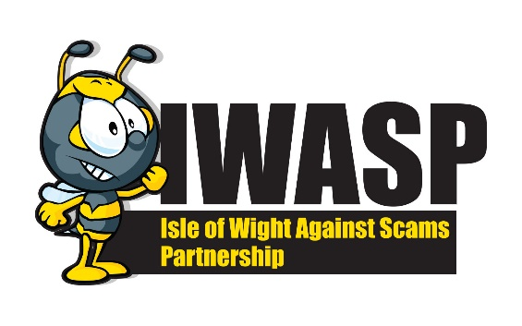
GUIDE TO ENGAGING A TRADER

Engaging a trader to carry out work on your property can be a minefield. Who do you choose? Trading Standards have put together some information that you may find useful in helping you find a trader that wont let you down or cause you any issues.
Finding a Trader
Most of us these days will find a trader by going online, this might be through a search engine or a social media site, however traders will also still advertise in local magazines and the County Press. However you find a trader always make sure that you carry out some research seeking guidance and pre-shopping advice before engaging a trader for home improvements work. This might include references, reviews or recommendations from friends and family. If a trader claims to be a member of a professional body or trader association check this yourself – don’t believe it to be true. You could ask to see examples of other work the trader has carried out in the area.
Always obtain more than one quote, this will give you a good picture of what price seems acceptable. Timeframes are something else to consider, one trader may be cheaper but you may have to wait longer and vice versa so consider how important getting the job done is to you. We would also recommend arranging a payment schedule with your trader, you will then know how much you are going to pay throughout the contract and when.
Always make sure that you obtain the traders full name and address – you will need this information if anything goes wrong and you need to pursue them in court
None of this will guarantee that you find a trader that wont cause you problems but it will help to reduce the risk
Trader Approval Schemes
There are various trader approval schemes nationally including Buy With Confidence and Check a Trade. Trading Standards on the Island operates their own local scheme which mirrors the national ones but is solely for Island traders called the Isle of Wight Trader Approval Scheme. Traders on the scheme have been rigorously vetted to ensure that they meet the terms and conditions and we expect them to operate within the law.
Do not mistake these schemes for companies that match you with a trader. You can post an advert on their site and then traders respond. These, generally, DON’T carry out any vetting procedure and if you check the small print wont do anything if an issue arises. Anyone, skilled or not, can respond to your request – these are NOT trader approval schemes.

Legislation
Any consumer to trader contract is protected under the Consumer Rights Act 2015. This is civil legislation and the consumer can seek advice from the Citizens Advice Helpline for any issue around a traders contract on 0808 223 1133.
When you agree a contract with a trader either at your own premises or through distance selling (internet, phone etc) and the contract is for more than £42 you are protected by The Consumer Contract Regulations 2015. These stipulate that the trader has to provide you with certain pre-contract information such as their details and you will have 14 days to cancel this contract. The trader must also give you a cancellation notice and if you want the work to commence within the 14 days you must sign this. Failure by the trader to provide this could render the contract void. You can still cancel within this time frame but you may be liable for any work carried out.
What can Trading Standards do?
Trading Standards can no longer provide civil advice so if you encounter problems with your trader you should try to sort these out as amicably as possible in the first instance. If you cannot resolve the issues then contact the Citizens Advice Helpline (see above) where you will be given advice and guidance around what steps you will need to take to resolve the issue. This information will be shared with Trading Standards and logged on our database.
Doorstep selling
These are criminals, they will target areas where they feel vulnerable residents may live. They will then knock on doors, generally claiming to be working in the area and offer to carry out work on your property.
They will offer to do work for what seems like a reasonable price but will invariably find problems halfway through the job and the price will escalate. They will rarely be trained or qualified in carrying out the services they offer which means a poor job – you will then have to pay more to a reputable trader to correct the problem. They will quickly turn from being very pleasant to using intimidation and threats.
Some tips to stay safe from doorstep traders –
- Never deal with anyone who knocks on your door out of the blue and offers to do work for you.
- If you have a flyer through the door this doesn’t mean they are a genuine trader, fliers are cheap and easy to produce and we see many rogue traders using them.
- Use a window or spy hole to see who is at the door or use a door chain if you have one. If you don’t know who is calling you don’t answer
- They may carry out inspections on areas you cant access, e.g. the loft or roof and they will claim to find problems, often showing you pictures, video or meter readings. These wont be genuine.
- Never allow anyone into your home that you don’t know
- Never allow a trader to take you to the bank
- Take time to consider your options, never feel pressured into making a decision – say NO
- Use a no cold calling door sticker – available from trading.standards@iow.gov.uk whilst this might not prevent the rogue trader from knocking your door, if they refuse to leave when asked they are committing an offence and we would recommend calling the police on 101
- If you see somebody knocking doors in your area please call Trading Standards on 823371 (office hours) or the Police on 101 giving as much information as you can
- If you have elderly family, friends or neighbours make sure they are aware of this information it could prevent them from becoming a victim in the future.

Most contracts will be performed in budget and on time however for those that aren’t this can be a very stressful time for the consumer. Take precautions to ensure you don’t fall fowl of a trader in your home.
HOW TO CHECK OR REPORT
Citizens Advice Scam Line – 0808 250 550
Action Fraud - Action Fraud - 03001232040
Trading Standards – trading.standards@iow.gov.uk
Trading Standards – 01983 823371

