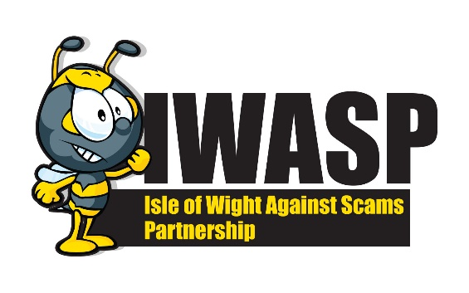
SCAM TIPS

Call Blocking
- If you are a WightFibre, Sky or TalkTalk customer they all offer a free call blocking service – Wightfibre – dial 1490 and follow instructions
- Talk Talk – dial 1472 and follow instructions
- Sky – call them directly or through your online account
- You can purchase phones that block scam calls and allow through calls from friends and family that are stored in the memory
- Call Blocking Units can be purchased online from reputable traders. Trading Standards works with Truecall to keep residents safe

What to do with Scams
- Scam emails can be forwarded to report@phishing.gov.uk
- If you receive a scam call purporting to be your bank you can call 159 to verify if it really was your bank or a scammer
- If you receive a scam text this can be forwarded to 7726
- If you receive a call and are unsure of the caller you can go to the Who Called Me website and put the number in and it will tell you if this is a trusted number or a scam
- If you want to check out a website before making a purchase got to Get Safe Online | The UK's leading Online Safety Advice Resource who have a website checker on their site

Warning signs it might be a scam
- If it sounds too good to be true: Beware of hype and extravagant promises. If it sounds too good to be true, it almost always is.
- You are contacted out of the blue: You may get a phone call, email or letter from someone you’ve never heard of.
- You have to make a quick decision: Scammers don’t like to give you time to think. They will try to pressure you into making a decision by saying things like ‘If you don’t act now, you’ll miss out.’
- You have to give away bank account details: Trustworthy firms will never contact you to ask for this information.
- Banks will never ask you to click on a link
If you see any of the warning signs in a letter, phone call, text message or email, it could well be a scam.

Useful Websites
IWASP IWASP - Isle of Wight Against Scams Partnership (iow.gov.uk)
Security.org Security.org: Security Doesn't Have to be Complicated
Get Safe Online Get Safe Online | The UK's leading Online Safety Advice Resource
Who Called Me Who called me? | United Kingdom's Free Reverse Phone Lookup (who-called.co.uk)

Remember - Take Five

Stop -Taking a moment to stop and think before parting with your money or information could keep you safe.
Challenge -Could it be fake? It’s ok to reject, refuse or ignore any requests. Only criminals will try to rush or panic you.
Protect - Contact your bank immediately if you think you’ve fallen for a scam and report it to Action Fraud.

HOW TO CHECK OR REPORT
Citizens Advice Scam Line – 0808 250 550
Action Fraud - Action Fraud - 03001232040
Trading Standards – trading.standards@iow.gov.uk
Trading Standards – 01983 823371

